# **Semantic HTML for SEO and Accessibility**

Mary Macharia

September 2025

## **Technical SEO Implementation:**

### **How semantic HTML tags (<header>, <article>, <nav>, <section>, <footer>, <main>, <aside>) improve search engine crawling and indexing**

The HTML tags appear in a way that human and the machine can read. In this way, they assist the developer and the browser to comprehend a web page’s content and structure. For example;

**<header>**

The <header> tag boosts search for introductory content and other navigation links. Inclusion of the heading elements, such as <h1> - <h6>, icon, authorship details or logo, also boosts search engine crawling and indexing. Use of multiple <header> elements across one document also boosts searching. However, they cannot be put in sections like <address>, <footer> and any other <header> elements.

**<nav>**

The <nav> element showcases different navigation links and assists screen readers or any assistive technologies to assess if they can overlook the initial version of a content.

**<main>**

The <main> element specifies a document’s main and unique content. This tag appears only once in a document, making it easier for indexing.

**<section>**

It helps split a page into sections, such as introduction and contact details, with each section having a different tag.

**<aside>**

Allows placing content within a sidebar, which is mainly related to the surrounding content.

**<article>**

The <article> tag indicates stand-alone content, which can be solely disseminated or reused, like a news article or a blog post.

**<footer>**

The <footer> shows a document’s footer section, mainly illustrating authorship, copyright, contact, links and sitemap details element, which makes search engine crawling and indexing easier.

### **Technical implementation examples showing proper markup structure**

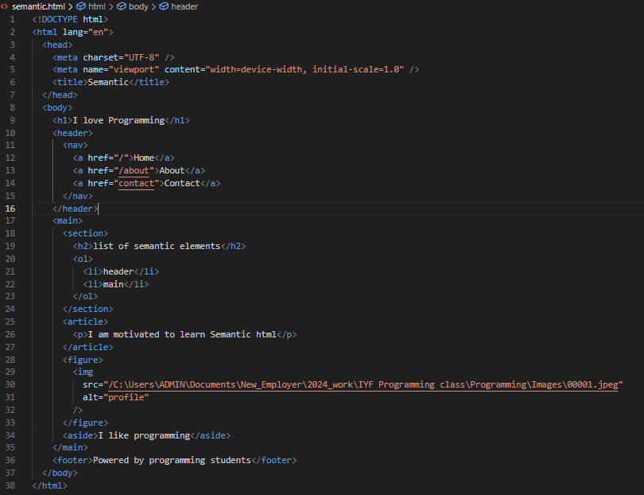

### **Code comparisons (semantic vs. non-semantic approaches)**

Semantic codes such as <nav> and <header> enhance organization of web content, boosting, and improve accessibility, helping BI developers, particularly users living with disabilities. However, non-semantic tags refer to generic containers that have no intrinsic meaning, applied for layout structuring, for instance, <span> and <div>. They make data parsing or interpretation dynamic and require extra attributes to make them interpretable. This way, one may say semantic codes help organize or structure web content while non-semantic are for aesthetic purposes. Overall, semantic approaches allow inclusive web development and high search engine ranking but too much non-semantic codes reduce accessibility.

### **Performance metrics and measurable SEO improvements**

Performance metrics and measurable SEO show the position of a website in Search Engine Result Pages (SERPs). This involves checking the website’s overall position, SERP ranking distribution, branded vs unbranded keywords, and relevant keywords’ ranking in the SERPs. Top performances are showcased as lower numbers. They include;

**Impressions**

These are counts for times a website appears in the search results for a user’s query. This way, improving a webpage’s visibility to potential visitors is key. A web owner may track total impressions, impressions for particular sets of keywords and a compared impression value of branded keywords and non-branded ones to determine the website’s general relevance and visibility in search results.

**Organic Search Traffic**

It includes the number of clicks, users or sessions driven to a website via non-paid search engine results. High ranks are showcased in search results and one should aim for this to get more users clicking it.

**Click-Through Rate (CTR)**

CTR evaluates the proportion of persons clicking on a website after seeing it in SERPs. The title tag and meta description help attract clicks from SERPs. Thorough monitoring of CTR shows how your website search results appeal to the users and may help indicate the potential impacts of any changes you make.

**Engagement Rate**

This evaluates the percentage of users who interact with a specific website by staying for over 10 seconds, clicking on something and then submitting a form. A higher engagement rate shows that individuals find a website’s content relevant and interesting. In contrast, a low engagement rate shows that users do not see what they need from your website.

**Domain Authority**

This is applied by third-party tools to show Google’s ranking of your site based on link authority.

**Referring domains and backlinks**

Includes the number of links pointing from one site to another and the internal links

High referring domains and backlinks are relevant to improving a website’s performance.

**Business-related metrics**

Business metrics like revenue, conversions, new leads, market share, customer churn, and customer lifetime value help determine the SEO performance.

## **Technical Accessibility Implementation:**

### **How semantic HTML enhances screen reader navigation and ARIA compatibility**

A HTML structure and meaning help screen readers to navigate a page. The screen understands the semantic tags and allows the users to jump between and reach the main content. Other tags, such as <hi>to <6>, showcase an appropriate hierarchy that allows easier reading by the screen readers, while elements such as <header> <sections> clarify the type of content presented.

ARIA (Accessible Rich Internet Applications) is applied to boost accessibility whenever native HTML falls short, mainly for custom widgets. However, semantic HTML minimizes the need for ARIA and perfects ARIA roles whenever used. This is because semantic elements have implicit ARIA roles and semantic tags also prevent redundancy or wrong ARIA roles since they allow cleaner code. Besides, semantic HTML offers meaningful structure for ARIA when the latter is not supported by a screen reader. Before reaching for ARIA, one should use semantics, and test its compatibility with screen readers. In addition, ARIA roles are only used to create custom components like modals.

### **Code examples demonstrating proper semantic structure for assistive technologies**

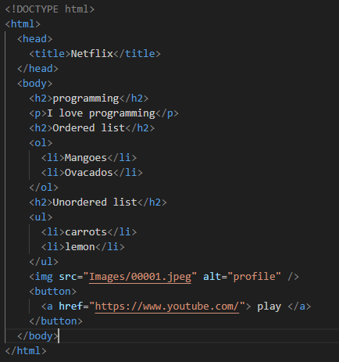

Each tags landmarks the specific content that allows readability of the entire website content.

### **Testing methodologies for accessibility compliance**

Tests for accessibility compliance guarantee that digital content can be used by persons with disabilities and that it meets web standards.

* **Manual Testing** to do what automated testing cannot do.
  + Navigate the keyboard to ensure all interactive elements, such as space and tab, work properly.
  + Test the screen reader to confirm if the content is announced right.
  + Evaluate color contrast.
  + Manage focus well.
  + Evaluate zoom and magnification to determine the content’s readability.

1. **Automated Testing** using tools like Tenon, Wave, axe-core and lighthouse.
   * Identifies missing alt text, ARIA errors, inappropriate heading structure, color contrast issues and form label errors.

* **Hybrid Testing**
  + Blends manual and automated testing methods for inclusive testing.
* **User Testing with People with Disabilities**
  + Determines real-world accessibility, offers feedback and develops empathy.
* **Trusted Tester Methodology (U.S. Federal Standard)**
  + Applied by government firms to guarantee adherence to Section 508.
  + Allows repeatable procedures, addresses standardized test cases, and allows certification for testers.
* **Accessibility Metrics & Reporting**
  + Track progress and impact by showing metrics such as numbers of violations for every page, satisfactory rates, and repetitive challenges.

### **d) Technical specifications for WCAG guidelines adherence**

* Following the perceivable principle where the content is required to be presented in a manner users can perceive, such as using captions, transcripts, proper color contrast, or the alt text, while supporting text resizing up to 200% without content loss.
* Adhere to the operable principle, where the interface elements should be used through keyboard and assistive technology. Skips links and clear focus indicators are highly recommended.
* Comply with the understandable principle that requires web content to be clear and predictable. The language must be clear, and error suggestions should be provided and navigation used consistently.
* Adhere to the robust principle that requires that the web content remains compatible with the present and upcoming technologies. This includes using semantic HTML for structure, ensuring ARIA roles are correctly applied, supporting assistive technologies across platforms and code validating to prevent parsing errors.

## **Implementation Best Practices:**

### **Step-by-step code examples with before/after comparisons**

**Non-semantic code- before**

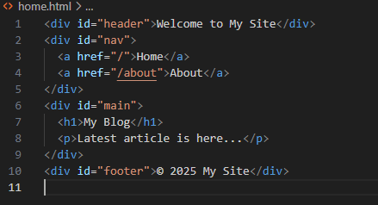

It displays

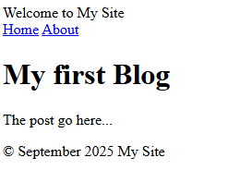

Has no semantic meaning for improved screen reading and SEO indexing.

**After using semantic codes**

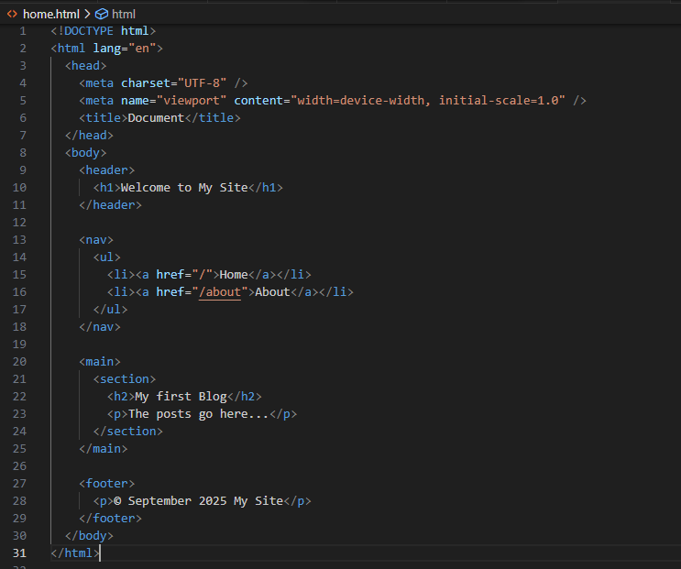

It shows

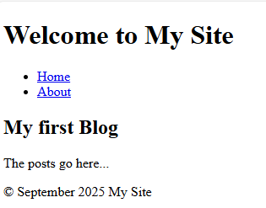

Replacing the <div> with semantic tags boosts the Website accessibility and SEO

**Before: Making forms using non-semantic codes**

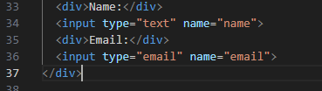

This gives

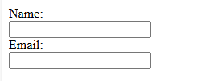

**After- using semantic codes**

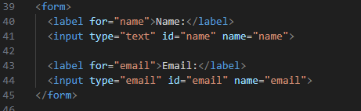

It appears, as shown below, with improved readability: there is improved use of semantic tags <form> and <label> that boost usability.

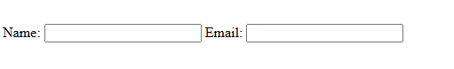

### **Common semantic HTML mistakes and how to avoid them**

* Misuse of code like <span> and <div> when structuring semantic HTML, yet they have no semantic meaning that makes it difficult for screen readers to interpret the layout.
* To avoid this, apply appropriate semantic tags, such as <nav> and <header>, for easy structuring and conveying of purpose.
* Forgetting to put heading levels that disrupts the logicality of content hierarchy. For instance, using <h1> and jumping to <h5>.
* Use headings as they follow each other to enable the search engines and screen readers to comprehend the content flow. For example, use <h1> for <main> , <h2> for <section> and <h3> for the next element.
* Incorrect use of elements, for example, use of <section> for blog post instead of using <article> for such stand-alone content and leave <section> for thematic grouping.
* Skipping some tags like <label> in making forms that make HTML inaccessible and unclear. So, one should always pair the input with the <label>. For example;

<label for="gender">Your gender:</label>

<input type="text" id="gender" name="gender">

* Overlooking the role of Landmark elements like <main>, <header>, <footer>, and <aside>. So always use them to landmark the page content.

### **Technical testing and validation methods;**

**Technical testing methods**: manual testing, automatic testing, hybrid testing, trusted tester methodology, accessibility metrics & reporting, and user testing with people with disabilities – discussed earlier in this post.

**Technical Validation methods:**

**Documentation:**

Sustains accessibility test cases, indicates WCAG conformance status, and reports violations.

**Integration Techniques:**

* Regression testing that guarantees accessibility even after updates.
* Custom rule development to modify automated tools into designing the system
* CI/CD Pipeline Integration: set in accessibility checks in the build and deployment work paths.

### **Performance impact analysis**

This requires comprehending a website’s responsiveness, speed, resource usage and how these impact users. It includes measuring

* Rendering performance using DevTools performance tab while minimizing layout shifts and long tasks that interrupt interactivity.
* Page Load Time using browser DevTools, optimizing with lazy loading, code splitting and compression and looking for large scripts, render-blocking resources and unoptimized images.
* Focus management to prevent overwhelming your users. You may use aria-live for automated announcing of updated content.

## **Practical Application:**

### **Real-world implementation scenarios**

**Used in news websites:**

* Helps structure articles for easier navigation and search engine indexing as semantic HTML elements like <header>, <article>, and <section> precisely define items of any news.

**Education websites**

* HTML semantics help in course content structuring that allows for enhanced user experience and accessibility for learners with visual and cognitive inabilities.

**Applied in technology blogs:**

* Organize posts for better readability for all users.

**Government portals:**

* Improve navigation for civic services and allow creation of shortcuts to accessing information for screen readers.

**E-Commerce Platforms:**

* Structures product listings for easier accessibility for search engines and screen readers.

### **Troubleshooting common semantic HTML issues**

The first step to troubleshoot a semantic HTML issue is to identify it. For example, identify any overuse of an element, wrong heading levels, and no alt text for images and determine what tool can easily help troubleshoot the problem. For instance,

* BrowserDevTools can help test keyboard navigation and inspect elements
* axe DevTools help check accessibility and semantic structure audits
* W3C HTML Validator Check for semantic and syntax errors

### **Integration with modern web development workflows**

Semantic HTML are integrated with:

* Component-based frameworks. For example, the react, angular, and Vue elements
* Design Systems
* Accessibility testing tools like WAVE, Lighthouse, accessibility Insights and axe DevTools that flag semantic errors such as improper heading levels and missing landmarks.
* Testing workflows
* CMS and headless architectures to customize templates, ensure rich text editors and validate rules for content structure.
* SEO workflows to enhance indexing.

### **Technical recommendations and standards**

***Recommendations:***

* Apply semantic HTML before ARIA roles.
* Apply semantic tags like <nav> instead of <span>/<div> to boost your website’s accessibility.
* Apply ARIA only for customized components when native semantics fall short.
* State document language used.
* Uphold heading levels hierarchy (<h1-> to <h6>) to improve readability and search engine indexing.
* Use the correcting semantic HTML elements, such as <header>, to make it easier for readers to assess specific details of the website content.

***Standards:***

* Meet World Wide Web Consortium (W3C) HTML Specification
* Adhere to WCAG (Web Content Accessibility Guidelines).
* *Correct use of semantic HTML boosts the structure, meaning, accessibility, readability and SEO of your web content.*